Tab 1

# 

# CSC 431 – Spring 2025

# **IntelliCup**

# **Software Requirements Specification (SRS)**

**Group 13**

| Sofia Papa | Team Member |
| --- | --- |
| Gargi Yadav | Team Member |
| Gabriel Huang | Team Member |

# 

# **Version History**

| **Version** | **Date** | **Author(s)** | **Change Comments** |
| --- | --- | --- | --- |
| **1.0** | 2/23 | Sofia Papa | Start of document. System requirements and system restraints. |
| **2.0** | 2/23 | Gargi Yadav | Changes made to the requirements to improve clarity and specify constraints. |
| **3.0** | 2/23 | Gargi Yadav | Added detailed use cases with actors and inserted diagrams to illustrate user interactions. |
| **4.0** | 2/24 | Gargi Yadav | Requirements Modeling with Use Case Diagrams. |
| **5.0** | 2/24 | Gabriel Huang | Evolutionary Requirements. |
| **6.0** | 2/24 | Gargi Yadav | Expanded Hardware Constraints. |
| **7.0** | 2/25 | Gargi Yadav | Refined Tables, Figures, and Use Case Diagrams. Improved clarity in Goal System tracking. |

# 

# **Table of Contents**

1. **System Requirements** 4

1.1 Functional Requirements 4

1.1.1 Liquid Identification 4

1.1.2 Consumption Tracking 5

1.1.3 User Dashboard 5

1.2 Non-Functional Requirements 6

1.2.1 Security 6

1.2.2 Performance 6

1.2.3 Usability 7

2. **System Constraints** 7

2.1 Tool Constraints 7

2.1.1 Front End Development Framework 7

2.1.2 Backend and Database Services 8

2.1.3 Version Control 8

2.1.4 Development Environment 8

2.1.5 Testing Tools 8

2.1.5 Deployment Tools 9

2.2 Language Constraints 9

2.2.1 Programming Languages 9

2.3 Platform Constraints 9

2.3.1 Mobile Application Compatibility 9

2.4 Hardware Constraints 10

2.4.1 Simulated Sensor Input 10

2.5 Network Constraints 10

2.5.1 Internet Dependency 10

2.6 Deployment Constraints 10

2.6.1 Mobile App Stores 10

2.7 Transition & Support Constraints 11

2.7.1 Maintenance & Updates 11

2.8 Budget & Schedule Constraints 11

2.8.1 Development Timeline 11

2.8.2 Cost 11

2.9 Miscellaneous Constraints 12

2.9.1 Legal Compliance 12

3. **Requirements Modeling** 12

3.1.1 Liquid Identification Use Case 13

3.1.2 Consumption Tracking Use Case 13

3.1.3 User Dashboard Use Case 14

3.1.4 Goal System Use Case 14

4. **Evolutionary Requirements** 15

4.1 Functional Requirements 15

4.1.1 Integrating AI Model 15

4.1.2 Adding Goal System 16

4.2 Non-Functional Requirements 16

4.2.1 Optimizing Processing Speed 16

4.2.2 Improving Accessibility 17

# **Table of Tables**

| **Table Number** | **Table Title** | **Page Number** |
| --- | --- | --- |
| 1.1.1 | Liquid Identification | 4 |
| 1.1.2 | Consumption Tracking | 5 |
| 1.1.3 | User Dashboard | 5 |
| 1.2.1 | Security | 6 |
| 1.2.2 | Performance | 6 |
| 1.2.3 | Usability | 7 |
| 2.1.1 | Front-end Development Framework | 7 |
| 2.1.2 | Back-end and Database Services | 8 |
| 2.1.3 | Version Control | 8 |
| 2.1.4 | Development Environment | 8 |
| 2.1.5 | Testing Tools | 8 |
| 2.1.6 | Deployment Tools | 9 |
| 2.2.1 | Programming Languages | 9 |
| 2.3.1 | Mobile Application Compatibility | 9 |
| 2.4.1 | Simulated Sensor Input | 10 |
| 2.5.1 | Internet Dependency | 10 |
| 2.6.1 | Mobile App Stores | 10 |
| 2.7.1 | Maintenance & Updates | 11 |
| 2.8.1 | Development Timeline | 11 |
| 2.8.2 | Cost | 11 |
| 2.9.1 | Legal Compliance | 12 |
| 4.1.1 | Integrating AI Model | 15 |
| 4.1.2 | Adding Goal System | 15 |
| 4.2.1 | Optimizing Processing Speed | 16 |
| 4.2.2 | Improving Accessibility | 16 |

# **Table of Figures**

| Figure Number | Figure Title | Page Number |
| --- | --- | --- |
| 3.1.1 | Liquid Identification Use Case | 12 |
| 3.1.2 | Consumption Tracking Use Case | 13 |
| 3.1.3 | User Dashboard Use Case | 13 |
| 3.1.4 | Goal System Use Case | 14 |

**1.** **System Requirements**

#### **1.1** **Functional Requirements**

##### Table 1.1.1

| Title | Liquid Identification |
| --- | --- |
| Description | The system must be able to identify the liquid type based on properties like color, density, pH, and conductivity. |
| Priority | 0 |
| Precondition(s) | The user pours liquid into the IntelliCup. |
| Basic Flow | 1. User pours liquid into IntelliCup. 2. System analyzes liquid properties 3. System classifies the liquid and sends results to the mobile app. |
| Postconditions(s) | The identified liquid is displayed on the app. |
| Use Case Diagram | See Section 3.1.1. |

##### 

##### Table 1.1.2

| Title | Consumption Tracking |
| --- | --- |
| Description | The system logs the user's liquid intake to monitor hydration and beverage choices. |
| Priority | 1 |
| Precondition(s) | The system has identified a liquid. |
| Basic Flow | 1. The system records the identified liquid. 2. The system updates the user’s consumption log. 3. The system provides insight to the user dashboard. |
| Postconditions(s) | The log updates and insights are displayed on the app. |
| Use Case Diagram | See Section 3.1.2 |

##### 

##### Table 1.1.3

| Title | User Dashboard |
| --- | --- |
| Description | A mobile interface displaying identified liquids, consumption history, and personalized recommendations. |
| Priority | 2 |
| Precondition(s) | The system has tracked consumption. |
| Basic Flow | 1. The system retrieves consumption data. 2. The system generates visual analytics. 3. The dashboard presents insights to the user. |
| Postconditions(s) | User views analytics and recommendations. |
| Use Case Diagram | See Section 3.1.3 |

**1.2** **Non-Functional Requirements**

##### Table 1.2.1

| Title | Security |
| --- | --- |
| Description | User data must be securely stored and encrypted to protect privacy. |
| Priority | 0 |
| Applicable FR(s) | Liquid Identification, Consumption Tracking, User Dashboard (Ensuring data encryption and secure access.) |

##### 

##### Table 1.2.2

| Title | Performance |
| --- | --- |
| Description | The IntelliCup system must process and classify a liquid within 3 seconds and update consumption tracking within 1 second after user interaction. The system should remain responsive and prevent lag under normal usage conditions. |
| Priority | 0 (High) |
| Applicable FR(s) | Liquid Identification (Ensuring quick classification of liquids), Consumption Tracking (Ensuring seamless data logging without delays), User Dashboard (Fast data retrieval for analytics and recommendations). |

##### 

##### Table 1.2.3

| Title | Usability |
| --- | --- |
| Description | The UI should be intuitive for all users, with accessibility considerations. |
| Priority | 2 |
| Applicable FR(s) | User dashboard |

### **2.** **System Constraints**

#### **2.1** **Tool Constraints**

##### Table 2.1.1

| Title | Front-end Development Framework |
| --- | --- |
| Description | React Native for cross-platform mobile app development. |
| Priority | 0 |

##### 

##### Table 2.1.2

| Title | Backend and Database Services |
| --- | --- |
| Description | Firebase for authentication, cloud storage, and real-time data handling. |
| Priority | 0 |

##### 

##### Table 2.1.3

| Title | Version Control |
| --- | --- |
| Description | Git and GitHub for source code management. |
| Priority | 1 |

##### 

##### Table 2.1.4

| Title | Development Environment |
| --- | --- |
| Description | Visual Studio Code (VS Code) as the primary IDE. |
| Priority | 1 |

##### 

##### Table 2.1.5

| Title | Testing Tools |
| --- | --- |
| Description | Jest for unit testing, Cypress for end-to-end testing. |
| Priority | 1 |

##### 

##### Table 2.1.6

| Title | Deployment Tools |
| --- | --- |
| Description | Expo for app deployment on iOS and Android platforms. |
| Priority | 1 |

#### **2.2** **Language Constraints**

##### Table 2.2.1

| Title | Programming Languages |
| --- | --- |
| Description | JavaScript (React Native), Python (backend), and SQL (database) |
| Priority | 1 |

**2.3** **Platform Constraints**

##### Table 2.3.1

| Title | Mobile Application Compatibility |
| --- | --- |
| Description | Must be compatible with iOS and Android. |
| Priority | 1 |

#### 

#### **2.4** **Hardware Constraints**

##### Table 2.4.1

| Title | Simulated Sensor Input |
| --- | --- |
| Description | The system will use simulated sensor data for liquid property detection, including color, density, pH, and conductivity. The mobile app will process these values to classify liquids. Future iterations may incorporate actual sensor integration. |
| Priority | 1 |

**2.5** **Network Constraints**

##### Table 2.5.1

| Title | Internet Dependency |
| --- | --- |
| Description | The system requires an internet connection for cloud storage and syncing. |
| Priority | 2 |

#### **2.6** **Deployment Constraints**

##### Table 2.6.1

| Title | Mobile App Stores |
| --- | --- |
| Description | The application must comply with App Store and Google Play guidelines. |
| Priority | 2 |

#### **2.7** **Transition & Support Constraints**

##### Table 2.7.1

| Title | Maintenance & Updates |
| --- | --- |
| Description | Requires periodic maintenance and software updates. |
| Priority | 3 |

#### **2.8** **Budget & Schedule Constraints**

##### Table 2.8.1

| Title | Development Timeline |
| --- | --- |
| Description | The project must be completed within the semester. |
| Priority | 0 |

##### 

##### Table 2.8.2

| Title | Cost |
| --- | --- |
| Description | The system should operate within a minimal budget using available cloud services. |
| Priority | 0 |

#### **2.9** **Miscellaneous Constraints**

##### Table 2.9.1

| Title | Legal Compliance |
| --- | --- |
| Description | Must comply with data privacy regulations (GDPR, CCPA). |
| Priority | 0 |

### **3.** **Requirements Modeling**

##### 3.1.1 Liquid Identification Use Case

##### 

##### 3.1.2 Consumption Tracking Use Case

##### 

##### 3.1.3 User Dashboard Use Case

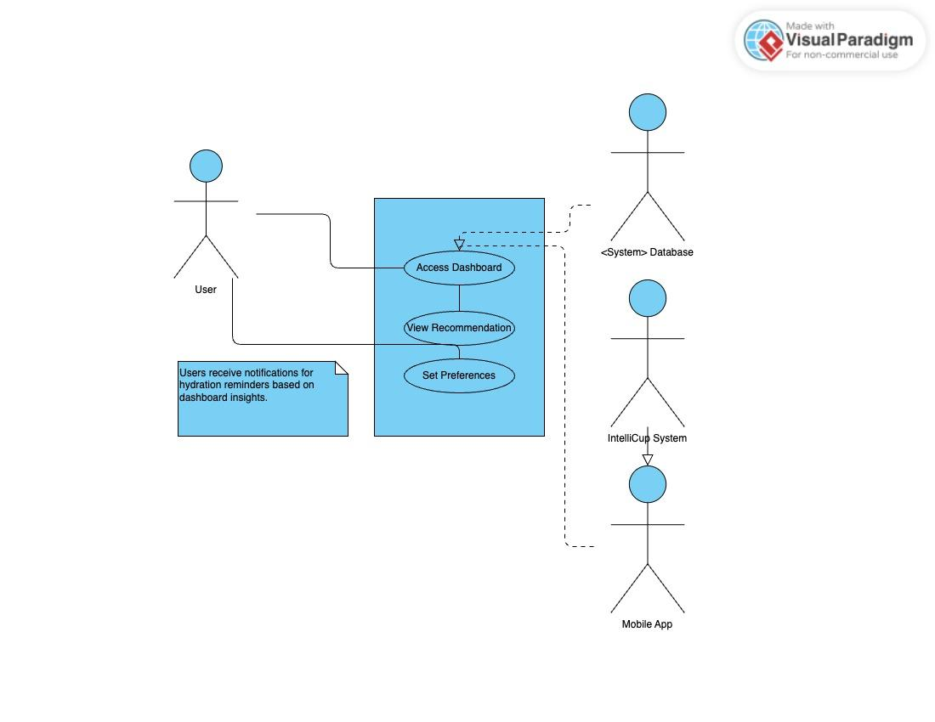

3.1.4 Goal System Use Case

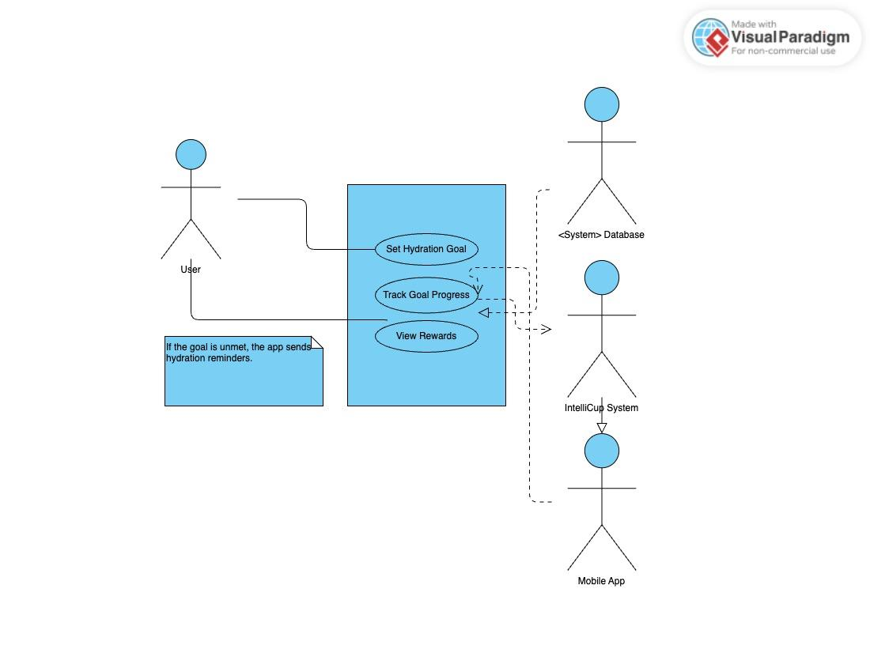

### **4.** **Evolutionary Requirements**

#### **4.1** **Functional Requirements**

##### 4.1.1 Integrating AI Model

| Title | AI-Based Liquid Classification |
| --- | --- |
| Description | Implement an ML model to classify liquids more accurately. |
| Priority | 1 |
| Precondition(s) | The system already collects liquid properties (color, density, pH, conductivity). |
| Postconditions(s) | The liquid classification is more accurate and adaptive over time. |
| Use Case Diagram | See 3.1.1, except with integrated model |

4.1.2 Adding Goal System

| Title | Hydration Goal Rewards |
| --- | --- |
| Description | Integrate a reward system for hydration goals. |
| Priority | 2 |
| Precondition(s) | The system tracks user consumption consistently. |
| Postconditions(s) | Users receive badges or points for hitting daily/weekly hydration targets. |
| Use Case Diagram | See 3.1.4 |

#### **4.2** **Non-Functional Requirements**

##### 4.2.1 Optimizing Processing Speed

| Title | Optimize Processing Speed |
| --- | --- |
| Description | Improve the liquid classification algorithm to reduce processing time to under 3 seconds. |
| Priority | 0 |
| Applicable FR(s) | Liquid Identification, Consumption Tracking |

#### 

#### 4.2.2 Improving Accessibility

| Title | Accessibility for Visually Impaired Users |
| --- | --- |
| Description | Improve accessibility features for visually impaired users. |
| Priority | 2 |
| Applicable FR(s) | User Dashboard |

#### 